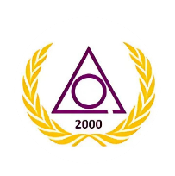 Russell Alexander Earl Sr. Grand Court
Ladies of the Circle of Perfection, Jurisdiction of Florida, Prince Hall Affiliated

Monthly Attendance Report
Please email a copy of this completed form with the RPM Monthly Report to: 9rgpm.locopfl@gmail.com and cc your Deputy, and Zone Coordinator within three (3) days of meeting.

Court Name: ___________________________________ RPM Name: _____________________________
Location: _________________________________________________________________________________
Email:__________________________________________ Phone: ________________________________

Print Last Name, First Name | Position | Attendance
1. | Royal Perfect Matron | Yes/No
2. | Royal Deputy Matron | Yes/No
3. | Royal Principal Conductress | Yes/No
4. | Royal Associate Conductress | Yes/No
5. | Royal Conductress of Ceremonies | Yes/No
6. | Royal Treasurer | Yes/No
7. | Royal Secretary | Yes/No
8. | Member | Yes/No
9. | Member | Yes/No
10. | Member | Yes/No
11. | Member | Yes/No
12. | Member | Yes/No
13. | Member | Yes/No
14. | Member | Yes/No
15. | Member | Yes/No
16. | Member | Yes/No
17. | Royal Chief Advisor | Yes/No
18. | Companion Guardian | Yes/No
19. | Deputy | Yes/No
20. | Zone Coordinator | Yes/No

Total in Attendance: ________
If the Meeting was held via Zoom please submit the date of approval. ___________________________

